Blood Donation and Emergency Donor Matching



CSC 2032 Object-Oriented Programming
N. Hirusha Wanigasingha

Group Members :-
M.I.S.Lakshani AS20240505
P.H.S.Vidusahan AS20240554

Submitted Date : 2026/07/24

Content
- Introduction
  - . Purpose
  - . Scope
  - . Definitions, Acronyms, and Abbreviations
  - . Overview

- Overall Description
  - Product Perspective
  - Product Functions
  - User Classes and Characteristics
  - Operating Environment
  - Constraints
  - Assumptions and Dependencies

- System Requirements
  - Functional Requirements
  - Non Functional Requirements

- UML Diagrams
  - Use Case Diagram
  - Class Diagram
  - Sequence Diagram
  - Activity Diagram

- Future Enhancements
- Conclusion
- References

- Introduction

  - Purpose
The purpose of this Software Requirements Specification (SRS) document is to define and describe the complete functional and non-functional requirements of the HemoLink - Blood Donation and Emergency Donor Matching System. This document serves as the formal agreement between the development team and stakeholders, providing a clear blueprint for the design, development, testing, and deployment of the system.
The HemoLink system is intended to digitize and automate the process of blood donor management, hospital blood request handling, inventory tracking, and intelligent donor-to-request matching, addressing the critical challenge of blood shortage management in the healthcare sector.
  - Scope
What the System Will Do:
The HemoLink system is a web-based platform that provides,
  - A centralized, role-based portal for three types of users: Administrators, Blood Donors, and Hospitals.
  - Automated donor matching for emergency blood requests using a compatibility scoring algorithm (0-100 scale) that considers blood group compatibility, geographic location, donor availability, and donation cooldown rules.
  - Blood stock inventory management with real-time unit tracking and low-stock alerts.
  - Donor registration and approval workflow to ensure only medically eligible and verified donors are active in the system.
  - Hospital registration and blood request management, allowing hospitals to submit, track, and fulfill blood requests.
  - Dashboard analytics using visual charts to present key metrics including inventory levels and donor distributions.
  - In-app notification system for all user roles.
  - Contact management module for public inquiries.

What the System Will Not Do:
  - The system will not manage financial transactions or payment processing.
  - The system will not integrate with external laboratory information systems or Electronic Health Records (EHR).
  - The system will not manage blood testing or medical screening results.
  - The system will not provide mobile application support in this version.
  - The system will not send SMS or email notifications in the current implementation.
Benefits of the System:
- Reduces time needed to find compatible blood donors during emergencies.
- Prevents blood wastage through inventory expiry tracking.
- Provides transparency and accountability through audit trails of donations and requests.
- Eliminates manual paper-based processes in blood bank management.

  - Definitions, Acronyms, and Abbreviations

Term / Acronym | Definition
SRS | Software Requirements Specification - a document describing the intended purpose, environment, and requirements for a software system
HemoLink | The name of the blood donation and emergency donor matching web system
MVC | Model-View-Controller - a software architectural pattern that separates application logic into three components
JDBC | Java Database Connectivity - a Java API that enables Java programs to execute SQL queries
DAO | Data Access Object - a design pattern that provides an abstract interface to the database
WAR | Web Application Archive - a packaged Java web application deployable on a server
POJO | Plain Old Java Object - a simple Java class with no special framework dependencies
Admin | System Administrator - a user with full control over the HemoLink platform
Donor | A registered blood donor user of the system
Hospital | A registered hospital or medical facility that submits blood requests
Blood Request | A formal request submitted by a hospital for a specific blood type and quantity
Matching Algorithm | The scoring logic that ranks eligible donors for a given blood request
Cooldown Period | The medically recommended minimum waiting period (56 days) between two consecutive donations
Rh Factor | Rhesus factor - a blood protein; donors/patients are either Rh positive (+) or Rh negative (−)
ABO | The ABO blood group classification system (A, B, AB, O)

1.4 Overview
This SRS document is organized as follows:
  - Section 1 (Introduction) introduces the purpose, scope, key definitions, and structure of this document.
  - Section 2 (Overall Description) provides a high-level view of the product, including its context, major functions, user types, operating environment, and assumptions.
  - Section 3 (System Requirements) defines detailed functional and non-functional requirements of the HemoLink system.
  - Section 4 (UML Diagrams) presents the Use Case Diagram, Class Diagram, Sequence Diagram, and Activity Diagram along with explanations.
  - Section 5 (Future Enhancements) outlines potential improvements planned for future versions.
  - Section 6 (Conclusion) summarizes the system and key points of the SRS.
  - Section 7 (References) lists all external resources, tools, and references used.

2. Overall Description

2.1 Product Perspective
HemoLink is a standalone web-based application developed as a university final-year project. It does not form part of a larger existing system; however, it is designed to operate independently as a complete blood donation management platform.
The system interacts with the following components:
- Web Browser (Client): Users access the system through a standard web browser (Chrome, Firefox, Edge). The frontend is served as static HTML/CSS/JS pages that communicate with the backend via HTTP/JSON API calls.
- Apache Tomcat Server: The Java Servlet-based backend is deployed on an Apache Tomcat web server, handling all business logic and data processing.
- MySQL Database Server: A relational MySQL database stores all persistent data including user accounts, donor profiles, hospital records, blood requests, inventory units, and notifications.
The system follows the MVC (Model-View-Controller) architectural pattern, ensuring clean separation between the data layer, business logic, and presentation layer.

2.2 Product Functions
The following summarizes the major functions of the HemoLink system:

- User Authentication & Session Management - Secure login and logout for Admin, Donor, and Hospital users with role-based session control.
- Donor Registration & Management - New donor self-registration, admin approval workflow, profile management, and eligibility tracking.
- Hospital Registration & Management - New hospital self-registration, admin approval workflow, and hospital profile management.
- Blood Request Submission & Tracking - Hospitals submit blood requests with urgency levels; admins and donors can view and respond to requests.
- Automated Donor Matching - Algorithm-based matching of donors to open blood requests using a 0–100 compatibility score.
- Blood Stock Inventory Management - Track individual blood units (type, volume, expiry, status) with low-stock alert generation.
- Donation Records Management - Record, view, and manage completed and pending donation transactions.
- Dashboard Analytics - Visual summary of key metrics using Chart.js charts.
- Notification System - In-app notification delivery and read/unread management for all roles.
- System Settings Management - Admin-configurable system parameters (cooldown days, stock thresholds, age limits, etc.).
- Contact Module - Public contact form submission and admin-side message management.

2.3 User Classes and Characteristics
- Administrator
Attribute | Description
Role | System administrator with full access responsible for managing the entire HemoLink platform and ensuring smooth system operation.
Technical Skill | Moderate - comfortable using web-based administration dashboards and managing system configurations.
Responsibilities | Approve or reject donor and hospital registrations, manage blood stock inventory, monitor and process emergency blood requests, oversee donor matching operations, configure system settings, manage user accounts, generate reports, and view system analytics.
Access Level | Full access to all modules, records, reports, and administrative functions within the system.
Count | Typically 1-3 administrators per deployment, depending on the size and operational requirements of the organization.

- Blood Donor
Attribute | Description
Role | Registered individual who voluntarily donates blood and participates in emergency donor matching through the HemoLink system.
Technical Skill | Basic - able to use web forms, dashboards, and notification features with minimal technical knowledge.
Responsibilities | Create and maintain a personal donor profile, update availability status, respond to matched emergency blood requests, schedule and confirm donations, view donation history, receive notifications, and ensure profile information remains accurate.
Access Level | Limited access to their own profile, matched blood requests, donation history, availability status, and personal notifications.
Count | Multiple per deployment, potentially ranging from hundreds to thousands of registered donors depending on the system's coverage.

- Hospital
Attribute | Description
Role | Registered healthcare institution authorized to request blood and manage emergency blood donation requests through the HemoLink system.
Technical Skill | Basic to Moderate - hospital administrative staff familiar with web-based management systems.
Responsibilities | Submit blood requests, specify blood type and urgency, view matched donors, monitor request progress, confirm received donations, manage request history, and receive system notifications.
Access Level | Limited access to the hospital's own blood requests, matched donor information, donation records, request history, and notifications.
Count | Multiple per deployment, typically consisting of tens of hospitals or healthcare institutions depending on the deployment region.

2.4 Operating Environment
- Hardware:
Server Processor: Intel Core i3 or equivalent (2.0 GHz+)
Server RAM: 4 GB RAM minimum (8 GB recommended)
Storage: 10 GB available disk space
Client Device: Any device with a modern web browser and internet/network access.
- Software:
Server OS: Windows 10/11, any operating system supporting Java 8
Java Runtime: Java JDK 1.8 (Java 8)
Web Server: Apache Tomcat 9.x
Database: MySQL
Build Tool: Apache Maven 3.6+
Web Browser :Google Chrome
Development IDE: IntelliJ IDEA
Deployment Network: The HemoLink system can be deployed within a Local Area Network (LAN) for internal use or made available over the internet through a public IP address, allowing authorized users to access the system remotely.
Development Environment: During development and testing, XAMPP (Apache, MySQL, PHP) can be used as a local server environment to simplify application setup and database management.

2.5 Constraints

Technical Constraints
- The backend is developed in Java 8, which limits the use of modern Java features available in Java 11+.
- The system uses Java Servlets without a modern framework (e.g., Spring Boot), which may limit scalability for very large user bases.
- The frontend uses Vanilla CSS and JavaScript without a modern framework (e.g., React or Vue), which may increase development effort for complex user interface interactions.

Security Constraints
- Passwords must be stored using SHA-256 hashing. Plain-text password storage is not permitted.
- All role-sensitive API endpoints must verify session authentication before processing requests.

Organizational Constraints
- The system is developed as a university final-year project and is not intended for immediate commercial deployment without further testing and security hardening.
- All sample donor and hospital data used within the system is fictitious and provided solely for demonstration purposes.

Legal and Ethical Constraints
- The system must not store sensitive medical records beyond the information required to determine donation eligibility (e.g., age, weight, and relevant medical conditions).
- User data must be collected, stored, and processed in accordance with applicable data protection and privacy principles.

Top of Form
Bottom of Form

2.6 Assumptions and Dependencies
Assumptions
- It is assumed that all donors who register have provided truthful information regarding their health status and eligibility.
- It is assumed that hospital accounts represent genuine, licensed medical facilities.
- It is assumed that the system administrator is a trusted user with full system access.
- It is assumed that the 56-day donation cooldown is enforced strictly and no exceptions are manually overridden.
- It is assumed that the client machines have a stable internet or local network connection to access the system.
- It is assumed that blood unit expiry is automatically managed based on the configured expiry window (default: 42 days from collection).

Dependencies
- The system depends on Apache Tomcat being installed and running as the application server.
- The system depends on a running MySQL database server with the blood_donation_db schema correctly initialized via schema.sql.
- The system depends on the Google Gson library (com.google.code.gson:gson:2.10.1) for JSON processing.
- The system depends on the MySQL JDBC Connector (mysql-connector-java:8.0.33) for database connectivity.
- The dashboard charts depend on the availability of the Chart.js CDN or a locally bundled version.
- The system depends on Apache Maven for building and packaging the application.

3. System Requirements
  - Functional Requirements
Module 1: User Authentication & Session Management
- FR-001: User Login
The system shall allow registered users (Admin, Donor, Hospital) to log in using a valid username and SHA-256 hashed password. Upon successful login, the system shall create a session and redirect the user to their respective role-specific dashboard.
- FR-002: Role-Based Access Control
The system shall enforce role-based access control on all pages and API endpoints. Admin users shall access the admin dashboard, donor users shall access the donor dashboard, and hospital users shall access the hospital dashboard. Unauthorized access attempts shall be rejected with an appropriate error response.
- FR-003: User Logout
The system shall allow any logged-in user to log out. Upon logout, the system shall invalidate the current session and redirect the user to the login page.
- FR-004: Session Persistence
The system shall maintain the user session across page navigation within the same portal. If the session expires or becomes invalid, the user shall be redirected to the login page.

Module 2: Donor Registration & Management
- FR-005: Donor Self-Registration
The system shall allow unauthenticated users to register as a new blood donor by providing the following information: full name, username, password, email, phone number, blood type (A, B, AB, O), Rh factor (+ or −), age, gender, city, address, weight (kg), and any known medical conditions. The registration shall be submitted with an awaiting approval status.
- FR-006: Donor Registration Validation
The system shall validate donor registration inputs. Minimum age must be 18 years and maximum age must be 65 years. Minimum weight must be 50 kg. The username must be unique. All mandatory fields must be completed.
- FR-007: Admin Donor Approval
The system shall allow the Admin to view all pending donor registrations with status awaiting. The Admin shall be able to approve or reject each registration. Upon approval, the donor account status is set to approved and the donor may log in and use the system. Upon rejection, the status is set to rejected and the account is not activated.

- FR-008: Donor Profile Management
The system shall allow approved donors to view their own profile including personal details, blood type, total donations, eligibility status, and donation history.
- FR-009: Donor Availability Toggle
The system shall allow a donor to toggle their availability status (Available / Unavailable). Only donors marked as available shall be considered by the matching algorithm.
- FR-010: Donor Eligibility Check
The system shall automatically calculate and display whether a donor is eligible to donate based on the 56-day cooldown from the last donation date. Donors within the cooldown period shall not be matched or allowed to respond to blood requests.
FR-011: Admin Donor Management
The system shall allow the Admin to view a list of all registered donors, filter by status, and view individual donor profiles including donation history.

Module 3: Hospital Registration & Management
- FR-012: Hospital Self-Registration
The system shall allow unauthenticated users to register a hospital by providing: hospital name, username, password, email, phone number, city, address, license number, and hospital type (Government / Private / Non-Profit). The registration shall be submitted with an awaiting status.
- FR-013: Admin Hospital Approval
The system shall allow the Admin to view all pending hospital registrations and approve or reject each one. Approved hospitals gain access to the hospital portal. Rejected hospitals cannot log in.
- FR-014: Hospital Profile View
The system shall allow approved hospital users to view their own hospital profile and registration details.

Module 4: Blood Request Management
- FR-015: Hospital Blood Request Submission
The system shall allow an approved hospital user to submit a blood request by specifying: patient name, required blood type and Rh factor, number of units needed, urgency level (Critical / Urgent / Routine), required date, contact person, phone number, and any additional notes. A unique reference ID shall be auto-generated for each request.
- FR-016: Blood Request Status Tracking
The system shall allow hospitals to view the status of all their submitted blood requests. Possible statuses include: pending, matching, accepted, fulfilled, completed, and cancelled.
- FR-017: Admin Blood Request Management
The system shall allow the Admin to view all blood requests across all hospitals, filter by status or urgency, and update request statuses as needed.
- FR-018: Donor Response to Blood Request
The system shall allow matched donors to accept or decline a blood request. Upon acceptance, the donor's response shall be recorded and the hospital notified.

Module 5: Automated Donor Matching
- FR-019: Donor Matching Algorithm
The system shall automatically match eligible donors to open blood requests using a scoring algorithm (0–100 scale). The algorithm shall consider the following criteria:
Blood Group Compatibility (Primary): The donor's blood type and Rh factor must be compatible with the requested blood type according to the ABO/Rh compatibility matrix.
Geographic Location: Donors in the same city as the requesting hospital receive a higher score.
Availability Status: Only donors with is_available = TRUE and approval_status = approved are considered.
Donation Cooldown: Donors whose last donation date is within the 56-day cooldown period are excluded.
- FR-020: Matched Donor Notification
The system shall send in-app notifications to eligible matched donors informing them of a new blood request that matches their profile.
- FR-021: Admin Matching Trigger
The system shall allow the Admin to manually trigger or review the donor matching process for any open blood request and view the ranked list of matched donors with their scores.

Module 6: Blood Stock Inventory Management
- FR-022: Blood Unit Registration
The system shall allow the Admin to add new blood units to the inventory. Each unit record includes: blood type, Rh factor, volume (ml), collection date, expiry date, donor ID (if applicable), and initial status (available).
- FR-023: Blood Unit Status Management
The system shall support the following blood unit statuses: available, reserved, used, and expired. The Admin shall be able to update unit statuses as appropriate.
- FR-024: Low Stock Alert
The system shall monitor the total count of available blood units per blood type and Rh factor combination. If the count falls below the configurable low-stock threshold (default: 3 units), the system shall display a LOW STOCK warning on the Admin dashboard.
- FR-025: Blood Inventory Summary
The system shall display a real-time summary of blood stock grouped by blood type and Rh factor, showing available, reserved, used, and expired unit counts.

Module 7: Donation Record Management
- FR-026: Donation Record Creation
The system shall automatically create a donation record when a donor completes a blood donation linked to a hospital request. Each record includes: donor details, blood type, volume, donation date, hospital details, and a reference ID.
- FR-027: Donation History View
The system shall allow donors to view their complete donation history. The system shall allow hospitals to view donation records associated with their requests. The Admin shall have access to all donation records.

Module 8: Dashboard & Analytics
- FR-028: Admin Analytics Dashboard
The system shall provide the Admin with a visual dashboard displaying:
Total registered donors (approved, awaiting, rejected counts)
Total registered hospitals
Total blood requests (by status)
Total blood units in stock
Chart.js charts showing blood group inventory distribution and donor group distribution
- FR-029: Role-Specific Dashboards
The system shall provide Donor users with a dashboard showing their profile summary, eligibility status, recent notifications, and matched requests. The system shall provide Hospital users with a dashboard showing their submitted requests, matched donors, and recent notifications.

Module 9: Notifications & Contact
- FR-030: In-App Notification System
The system shall generate and deliver in-app notifications to users for the following events: new donor/hospital registration (to Admin), donor match found (to Donor), blood request update (to Hospital), registration approval/rejection (to Donor/Hospital). Users shall be able to view all notifications and mark them as read.
- FR-031: Contact Form Submission
The system shall allow unauthenticated public users to submit a contact inquiry by providing their name, email address, and message. The Admin shall be able to view and manage all submitted contact messages.

Module 10: System Settings
- FR-032: Admin System Settings Management
The system shall allow the Admin to view and update the following configurable system parameters via the settings panel:

  - . Non-Functional Requirements

Performance Requirements
- NFR-001: The system shall load any dashboard page within 3 seconds under normal operating conditions (single server, up to 100 concurrent users).
- NFR-002: The donor matching algorithm shall complete the scoring and ranking process for up to 500 donors within 5 seconds per request.
- NFR-003: Database queries for blood stock inventory summaries shall execute within 2 seconds under standard load conditions.
- NFR-004: The system shall be capable of handling at least 50 simultaneous active user sessions without performance degradation.
Security Requirements
- NFR-005: All user passwords must be stored in the database as SHA-256 cryptographic hashes. Plain-text passwords must never be stored or transmitted.
- NFR-006: All sensitive API endpoints (those that read or modify data) must validate that the requester has an active, authenticated session with the appropriate role before processing the request.
- NFR-007: The system shall prevent unauthorized cross-role access. A donor must not be able to access Admin or Hospital-specific pages or API endpoints.
- NFR-008: All user input received via forms shall be validated on both the frontend (JavaScript) and the backend (Java Servlet) to prevent malformed data from being persisted.
- NFR-009: The system shall implement session invalidation on logout to prevent session reuse after a user signs out.
Usability Requirements
- NFR-010: The user interface shall be intuitive and usable by non-technical users (hospital staff, donors) without requiring specialized training. Key actions (submit request, view status, check eligibility) shall be accessible within 3 clicks from the dashboard.
- NFR-011: The system shall provide clear feedback messages to users for all actions — confirming success (e.g., "Registration submitted successfully") or displaying meaningful error messages (e.g., "Invalid username or password").
- NFR-012: The system shall implement a dark-themed, responsive web interface that is readable and navigable on desktop browsers with a minimum resolution of 1280×720 pixels.
- NFR-013: The system shall display LOW STOCK warning banners in a visually distinct color (e.g., red or amber) to immediately draw administrator attention to critical inventory levels.

Reliability and Availability Requirements
- NFR-014: The system shall target a minimum uptime of 99% during business hours when deployed in a production-like environment.
- NFR-015: The system shall handle unexpected errors (e.g., database connection failure, malformed JSON) gracefully by logging the error and returning a user-friendly error message rather than crashing or displaying a stack trace to the user.
- NFR-016: The database shall use foreign key constraints with appropriate cascade rules (ON DELETE CASCADE, ON DELETE SET NULL) to maintain referential integrity and prevent orphaned records.
- NFR-017: All blood unit expiry tracking shall be based on the server date at the time of record creation, ensuring consistency regardless of the client's local timezone.

4. UMLDiagrams
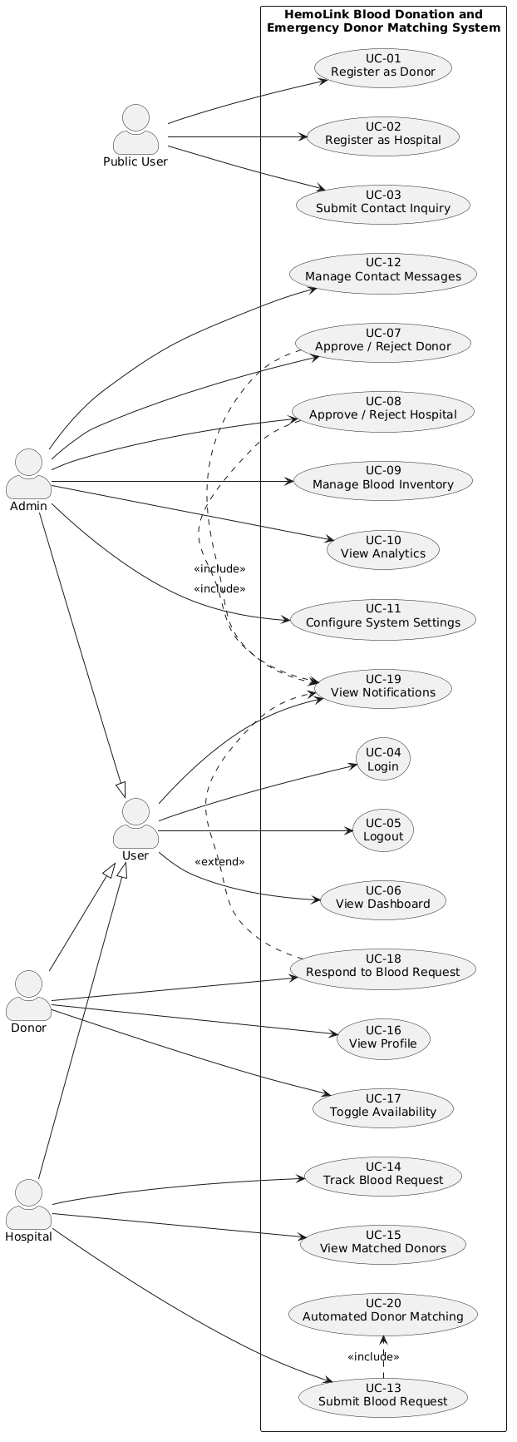
4.1 Use Case Diagram

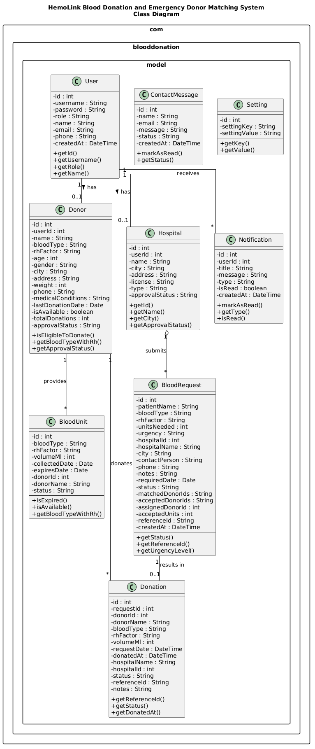
4.2 Class Diagram

4.3 Sequence Diagram
Hospital Submits a Blood Request and Receives Matched Donors
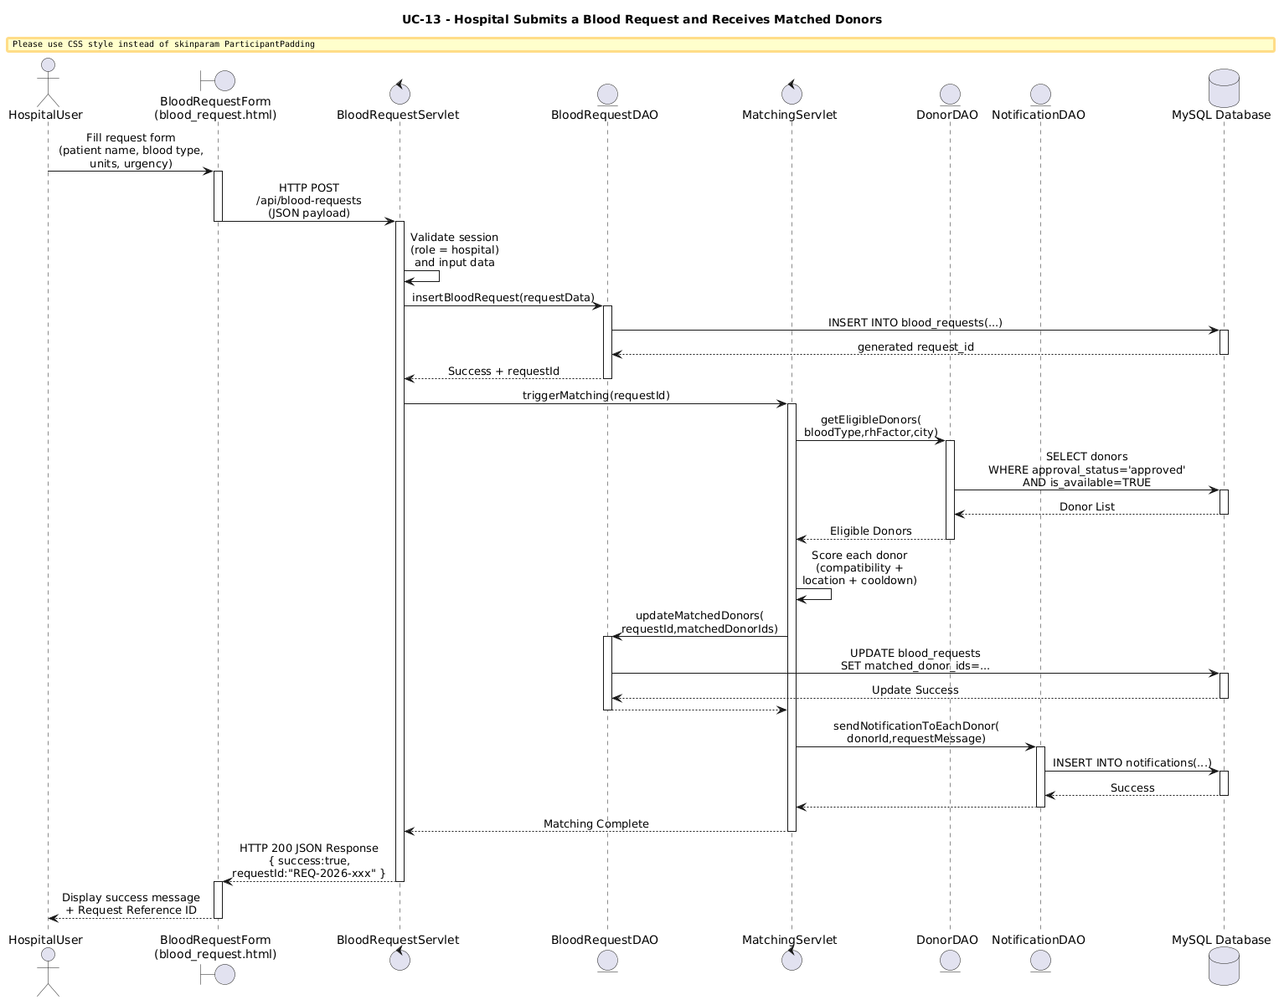

4.3 Activity Diagram
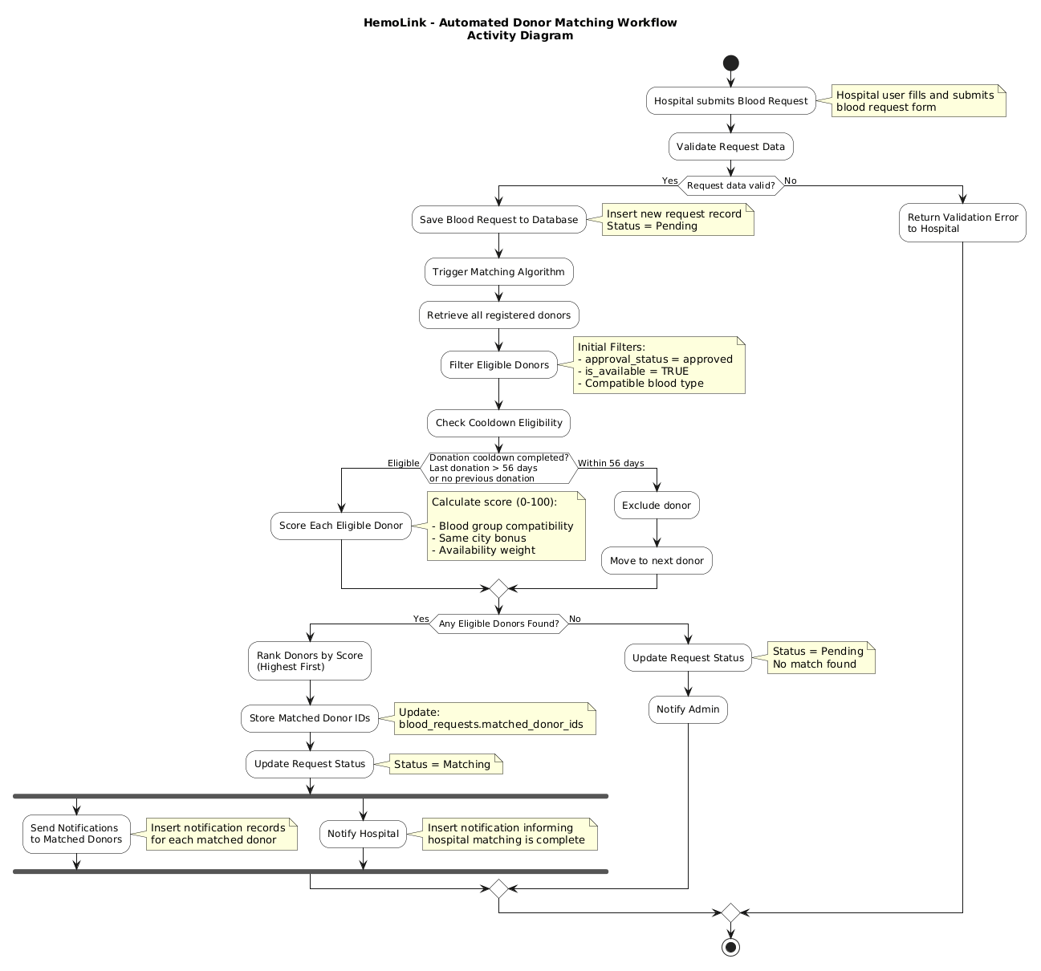
Automated Donor Matching Workflow

5. Future Enhancements
  - SMS and Email Notifications: Integrate an SMS gateway (e.g., Twilio) and email service (e.g., JavaMail API / SendGrid) to send real-time alerts to donors and hospitals when a match is found or a request is updated.
  - Mobile Application: Develop native or hybrid mobile applications (Android/iOS) to allow donors to receive push notifications, manage availability, and respond to requests from their smartphones.
  - Advanced Compatibility Matching: Extend the matching algorithm to consider rare blood subtypes, platelet-only donations, plasma compatibility, and patient-specific antibody considerations.
  - GPS-Based Location Matching: Replace city-based location matching with GPS coordinate distance calculation to provide more accurate geographic proximity scoring.
  - Automated Expiry Management: Implement a scheduled background task (e.g., a Java Timer or cron job) to automatically update expired blood units and generate expiry reports.
  - Reporting and Export: Add PDF and Excel export features for donation reports, inventory summaries, and blood request history.
  - Spring Boot Migration: Migrate the backend from raw Java Servlets to the Spring Boot framework for improved maintainability, testing support, and scalability.
  - REST API for Integration: Expose a documented RESTful API to allow integration with external hospital information systems and national blood bank databases.
  - Multi-Language Support: Add Sinhala and Tamil language support to the user interface to improve accessibility for Sri Lankan users.
  - Donor Health Questionnaire: Add a digital pre-donation health screening questionnaire that donors must complete before each donation response, further ensuring donor eligibility and safety.

6. Conclusion
The HemoLink Blood Donation and Emergency Donor Matching System addresses a critical real-world problem in healthcare - the efficient management of blood supply and the rapid identification of compatible donors during medical emergencies. This SRS document has comprehensively defined the system's purpose, scope, user classes, operating environment, constraints, assumptions, functional requirements (FR-001 to FR-032), and non-functional requirements across performance, security, usability, and reliability dimensions.

The system's architecture follows a clean MVC pattern with a Java Servlet backend, MySQL relational database, and HTML/CSS/JavaScript frontend. Its key innovation - the automated donor matching algorithm - provides a transparent, rules-based scoring mechanism that prioritizes patient safety through blood compatibility rules, geographic proximity, and medically mandated donation cooldown enforcement.

The UML diagrams presented in this document - the Use Case Diagram, Class Diagram, Sequence Diagram, and Activity Diagram - collectively provide a complete visual blueprint of the system's actors, domain model, interaction flows, and business process workflows.
HemoLink, as defined in this SRS, represents a practical, scalable, and secure foundation for a modern blood donation coordination platform that can significantly improve emergency response times, reduce blood wastage, and save lives.

7. References
- Sommerville, I. (2016). Software Engineering (10th ed.). Pearson Education.
- IEEE Computer Society. (1998). IEEE Recommended Practice for Software Requirements Specifications (IEEE Std 830-1998). IEEE.
- Apache Software Foundation. (2024). Apache Tomcat 10 Documentation. Retrieved from https://tomcat.apache.org/tomcat-10.0-doc/
- Oracle Corporation. (2024). Java Servlet Technology Overview. Retrieved from https://www.oracle.com/java/technologies/java-servlet-tec.html
- MySQL. (2024). MySQL 8.0 Reference Manual. Oracle Corporation. Retrieved from https://dev.mysql.com/doc/refman/8.0/en/
- Apache Maven Project. (2024). Maven – Introduction. Retrieved from https://maven.apache.org/what-is-maven.html
- Google. (2024). Gson User Guide. Retrieved from https://github.com/google/gson/blob/master/UserGuide.md
- Chart.js Contributors. (2024). Chart.js Documentation. Retrieved from https://www.chartjs.org/docs/latest/
- National Blood Transfusion Service. (2024). Blood Compatibility and Donation Guidelines. Ministry of Health, Sri Lanka.
- draw.io (diagrams.net). (2024). Free Online Diagram Software. Retrieved from https://app.diagrams.net/
- Lucidchart. (2024). UML Diagram Tool. Lucid Software. Retrieved from https://www.lucidchart.com/

